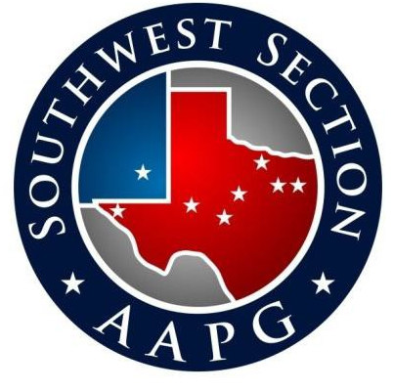
Presents the 2022 Bill Hailey Memorial Short Course
From Moho to Methane Molecule: The Geoscience Drivers Behind the Permian Basin’s Evolution from Conventional to Unconventional Greatness
By Andy Pepper, This is Petroleum Systems LLC

Tuesday January 25th, 2022
Abilene, Texas
Hardin-Simmons University:
Houston-Lantrip / William Watt Matthews Conference Center
917 Lineberry Blvd, Abilene, Texas 79601

Registration: 8:00 – 8:30 am
Morning Program: 8:30 – Noon
Lunch: Noon – 1:00 pm
Afternoon Program: 1:00– 5:00 pm

Event will be In-Person/Virtual streaming via Zoom, CLASSROOM SPACE IS LIMITED to the first 110 participants then will be Virtual only

Register Online at www.fwgs.org
Navigate to the events page, choose Abilene short course In-person or Virtual

The SWS provides the course free of charge for AAPG Members residing in the SWS or current members of a SWS affiliated Geological Society, however, there is an all-day food/refreshment and materials fee of $60 (in Person) or $5 (virtual)

SWS local Society Member or AAPG Member ………….……….... In-Person $60 Virtual $5
Non-Member Pre-registration…………………………….………...… In-Person $80 Virtual $50

Current College/University Students w/ a Geoscience Major……………... In-Person or Virtual (Free with current status confirmation)

